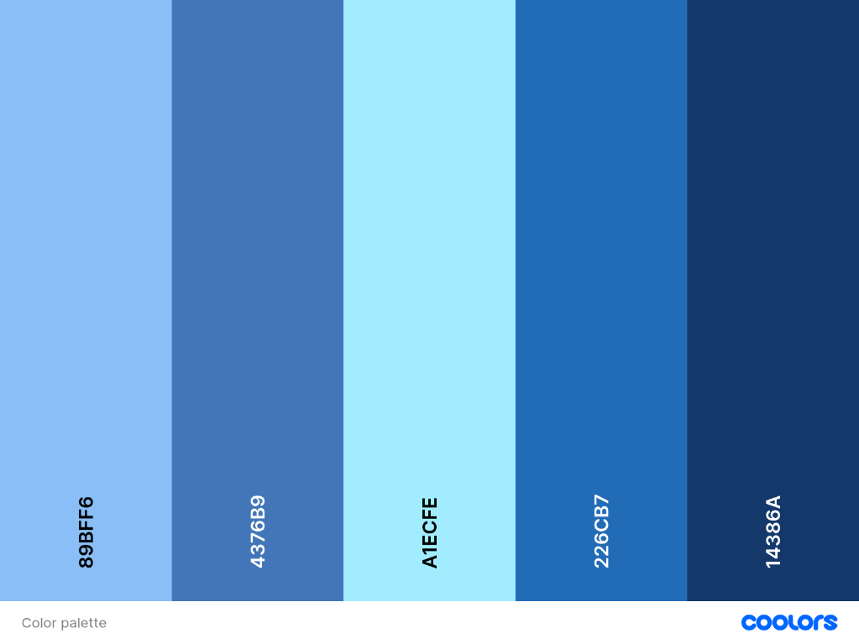
Шрифт – Articulat CF
Color pallete
а также белый и 060E1E - для темных участков, весь сайт с использованием этих цветов.

Главная концепция сайта — это меньше – больше. По минимуму лишней информации, которая отвлекает внимание и т.д. Заказчик хочет посмотреть на работы и оценить меня как человека, способного исправить его проблему (именно монтаж)

Первое что мы видим при заходе на сайт, вместо надписи Neura Flow - Hello! (Hello) появляется по позиции снизу по с opacity (0%) и блюром или лучше вот так:
import { DiaTextReveal } from "@/registry/magicui/dia-text-reveal"

export function DiaTextRevealDemo() {
return (
<div className="flex min-h-64 items-center justify-center p-8">
<DiaTextReveal
className="text-4xl font-bold tracking-tight"
text="Magic UI"
colors={["#A97CF8", "#F38CB8", "#FDCC92"]}
/>
</div>
)
}
https://magicui.design/docs/components/dia-text-reveal
+ если что частички белые над сферой которые плавно двигаются вправо


И далее при пролистывании ниже как бы идет разрыв этой сферы выше с появлением вот этой линии или просто плавный переход:

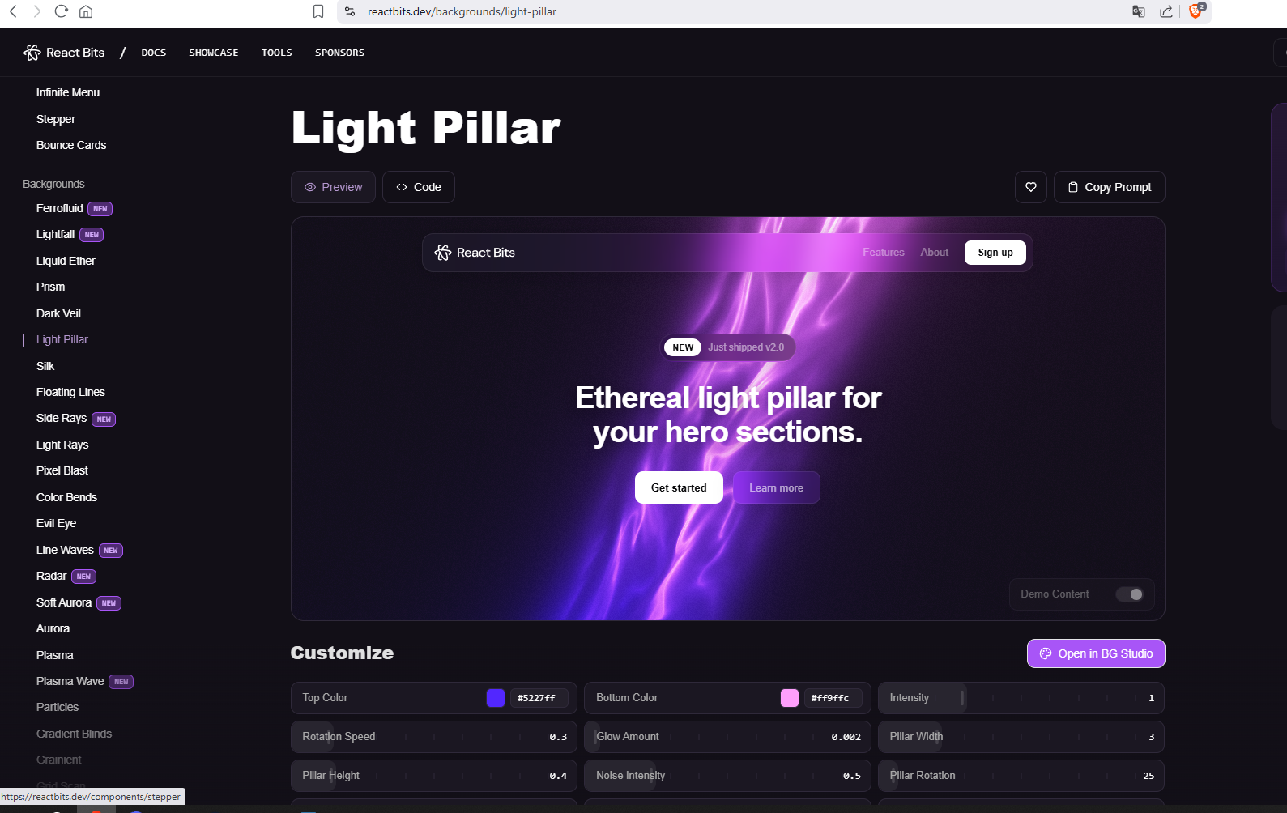
npx shadcn@latest add @react-bits/LightPillar-TS-CSS
import React, { useRef, useEffect, useState } from 'react';
import * as THREE from 'three';
import './LightPillar.css';

interface LightPillarProps {
topColor?: string;
bottomColor?: string;
intensity?: number;
rotationSpeed?: number;
interactive?: boolean;
className?: string;
glowAmount?: number;
pillarWidth?: number;
pillarHeight?: number;
noiseIntensity?: number;
mixBlendMode?: React.CSSProperties['mixBlendMode'];
pillarRotation?: number;
quality?: 'low' | 'medium' | 'high';
}

const LightPillar: React.FC<LightPillarProps> = ({
topColor = '#5227FF',
bottomColor = '#FF9FFC',
intensity = 1.0,
rotationSpeed = 0.3,
interactive = false,
className = '',
glowAmount = 0.005,
pillarWidth = 3.0,
pillarHeight = 0.4,
noiseIntensity = 0.5,
mixBlendMode = 'screen',
pillarRotation = 0,
quality = 'high'
}) => {
const containerRef = useRef<HTMLDivElement>(null);
const rafRef = useRef<number | null>(null);
const rendererRef = useRef<THREE.WebGLRenderer | null>(null);
const materialRef = useRef<THREE.ShaderMaterial | null>(null);
const sceneRef = useRef<THREE.Scene | null>(null);
const cameraRef = useRef<THREE.OrthographicCamera | null>(null);
const geometryRef = useRef<THREE.PlaneGeometry | null>(null);
const mouseRef = useRef<THREE.Vector2>(new THREE.Vector2(0, 0));
const timeRef = useRef(0);
const rotationSpeedRef = useRef(rotationSpeed);
const [webGLSupported, setWebGLSupported] = useState<boolean>(true);

// Check WebGL support
useEffect(() => {
const canvas = document.createElement('canvas');
const gl = canvas.getContext('webgl') || canvas.getContext('experimental-webgl');
if (!gl) {
setWebGLSupported(false);
}
}, []);

useEffect(() => {
if (!containerRef.current || !webGLSupported) return;

const container = containerRef.current;
const width = container.clientWidth;
const height = container.clientHeight;

const isMobile = /Android|webOS|iPhone|iPad|iPod|BlackBerry|IEMobile|Opera Mini/i.test(navigator.userAgent);
const isLowEndDevice = isMobile || (navigator.hardwareConcurrency && navigator.hardwareConcurrency <= 4);

let effectiveQuality = quality;
if (isLowEndDevice && quality === 'high') effectiveQuality = 'medium';
if (isMobile && quality !== 'low') effectiveQuality = 'low';

const qualitySettings = {
low: { iterations: 24, waveIterations: 1, pixelRatio: 0.5, precision: 'mediump', stepMultiplier: 1.5 },
medium: { iterations: 40, waveIterations: 2, pixelRatio: 0.65, precision: 'mediump', stepMultiplier: 1.2 },
high: {
iterations: 80,
waveIterations: 4,
pixelRatio: Math.min(window.devicePixelRatio, 2),
precision: 'highp',
stepMultiplier: 1.0
}
};

const settings = qualitySettings[effectiveQuality] || qualitySettings.medium;

const scene = new THREE.Scene();
sceneRef.current = scene;
const camera = new THREE.OrthographicCamera(-1, 1, 1, -1, 0, 1);
cameraRef.current = camera;

let renderer: THREE.WebGLRenderer;
try {
renderer = new THREE.WebGLRenderer({
antialias: false,
alpha: true,
powerPreference: effectiveQuality === 'high' ? 'high-performance' : 'low-power',
precision: settings.precision as 'highp' | 'mediump' | 'lowp',
stencil: false,
depth: false
});
} catch (error) {
setWebGLSupported(false);
return;
}

renderer.setSize(width, height);
renderer.setPixelRatio(settings.pixelRatio);
container.appendChild(renderer.domElement);
rendererRef.current = renderer;

const parseColor = (hex: string): THREE.Vector3 => {
const color = new THREE.Color(hex);
return new THREE.Vector3(color.r, color.g, color.b);
};

const vertexShader = `
varying vec2 vUv;
void main() {
vUv = uv;
gl_Position = vec4(position, 1.0);
}
`;

const fragmentShader = `
precision ${settings.precision} float;

uniform float uTime;
uniform vec2 uResolution;
uniform vec2 uMouse;
uniform vec3 uTopColor;
uniform vec3 uBottomColor;
uniform float uIntensity;
uniform bool uInteractive;
uniform float uGlowAmount;
uniform float uPillarWidth;
uniform float uPillarHeight;
uniform float uNoiseIntensity;
uniform float uRotCos;
uniform float uRotSin;
uniform float uPillarRotCos;
uniform float uPillarRotSin;
uniform float uWaveSin;
uniform float uWaveCos;
varying vec2 vUv;

const float STEP_MULT = ${settings.stepMultiplier.toFixed(1)};
const int MAX_ITER = ${settings.iterations};
const int WAVE_ITER = ${settings.waveIterations};

void main() {
vec2 uv = (vUv * 2.0 - 1.0) * vec2(uResolution.x / uResolution.y, 1.0);
uv = vec2(uPillarRotCos * uv.x - uPillarRotSin * uv.y, uPillarRotSin * uv.x + uPillarRotCos * uv.y);

vec3 ro = vec3(0.0, 0.0, -10.0);
vec3 rd = normalize(vec3(uv, 1.0));

float rotC = uRotCos;
float rotS = uRotSin;
if(uInteractive && (uMouse.x != 0.0 || uMouse.y != 0.0)) {
float a = uMouse.x * 6.283185;
rotC = cos(a);
rotS = sin(a);
}

vec3 col = vec3(0.0);
float t = 0.1;

for(int i = 0; i < MAX_ITER; i++) {
vec3 p = ro + rd * t;
p.xz = vec2(rotC * p.x - rotS * p.z, rotS * p.x + rotC * p.z);

vec3 q = p;
q.y = p.y * uPillarHeight + uTime;

float freq = 1.0;
float amp = 1.0;
for(int j = 0; j < WAVE_ITER; j++) {
q.xz = vec2(uWaveCos * q.x - uWaveSin * q.z, uWaveSin * q.x + uWaveCos * q.z);
q += cos(q.zxy * freq - uTime * float(j) * 2.0) * amp;
freq *= 2.0;
amp *= 0.5;
}

float d = length(cos(q.xz)) - 0.2;
float bound = length(p.xz) - uPillarWidth;
float k = 4.0;
float h = max(k - abs(d - bound), 0.0);
d = max(d, bound) + h * h * 0.0625 / k;
d = abs(d) * 0.15 + 0.01;

float grad = clamp((15.0 - p.y) / 30.0, 0.0, 1.0);
col += mix(uBottomColor, uTopColor, grad) / d;

t += d * STEP_MULT;
if(t > 50.0) break;
}

float widthNorm = uPillarWidth / 3.0;
col = tanh(col * uGlowAmount / widthNorm);

col -= fract(sin(dot(gl_FragCoord.xy, vec2(12.9898, 78.233))) * 43758.5453) / 15.0 * uNoiseIntensity;

gl_FragColor = vec4(col * uIntensity, 1.0);
}
`;

const pillarRotRad = (pillarRotation * Math.PI) / 180;
const waveSin = Math.sin(0.4);
const waveCos = Math.cos(0.4);

const material = new THREE.ShaderMaterial({
vertexShader,
fragmentShader,
uniforms: {
uTime: { value: 0 },
uResolution: { value: new THREE.Vector2(width, height) },
uMouse: { value: mouseRef.current },
uTopColor: { value: parseColor(topColor) },
uBottomColor: { value: parseColor(bottomColor) },
uIntensity: { value: intensity },
uInteractive: { value: interactive },
uGlowAmount: { value: glowAmount },
uPillarWidth: { value: pillarWidth },
uPillarHeight: { value: pillarHeight },
uNoiseIntensity: { value: noiseIntensity },
uRotCos: { value: 1.0 },
uRotSin: { value: 0.0 },
uPillarRotCos: { value: Math.cos(pillarRotRad) },
uPillarRotSin: { value: Math.sin(pillarRotRad) },
uWaveSin: { value: waveSin },
uWaveCos: { value: waveCos }
},
transparent: true,
depthWrite: false,
depthTest: false
});
materialRef.current = material;

const geometry = new THREE.PlaneGeometry(2, 2);
geometryRef.current = geometry;
const mesh = new THREE.Mesh(geometry, material);
scene.add(mesh);

let mouseMoveTimeout: number | null = null;
const handleMouseMove = (event: MouseEvent) => {
if (!interactive) return;

if (mouseMoveTimeout) return;

mouseMoveTimeout = window.setTimeout(() => {
mouseMoveTimeout = null;
}, 16);

const rect = container.getBoundingClientRect();
const x = ((event.clientX - rect.left) / rect.width) * 2 - 1;
const y = -((event.clientY - rect.top) / rect.height) * 2 + 1;
mouseRef.current.set(x, y);
};

if (interactive) {
container.addEventListener('mousemove', handleMouseMove, { passive: true });
}

let lastTime = performance.now();
const targetFPS = effectiveQuality === 'low' ? 30 : 60;
const frameTime = 1000 / targetFPS;

const animate = (currentTime: number) => {
if (!materialRef.current || !rendererRef.current || !sceneRef.current || !cameraRef.current) return;

const deltaTime = currentTime - lastTime;

if (deltaTime >= frameTime) {
timeRef.current += 0.016 * rotationSpeedRef.current;
const t = timeRef.current;
materialRef.current.uniforms.uTime.value = t;
materialRef.current.uniforms.uRotCos.value = Math.cos(t * 0.3);
materialRef.current.uniforms.uRotSin.value = Math.sin(t * 0.3);
rendererRef.current.render(sceneRef.current, cameraRef.current);
lastTime = currentTime - (deltaTime % frameTime);
}

rafRef.current = requestAnimationFrame(animate);
};
rafRef.current = requestAnimationFrame(animate);

let resizeTimeout: number | null = null;
const handleResize = () => {
if (resizeTimeout) {
clearTimeout(resizeTimeout);
}

resizeTimeout = window.setTimeout(() => {
if (!rendererRef.current || !materialRef.current || !containerRef.current) return;
const newWidth = containerRef.current.clientWidth;
const newHeight = containerRef.current.clientHeight;
rendererRef.current.setSize(newWidth, newHeight);
materialRef.current.uniforms.uResolution.value.set(newWidth, newHeight);
}, 150);
};

window.addEventListener('resize', handleResize, { passive: true });

return () => {
window.removeEventListener('resize', handleResize);
if (interactive) {
container.removeEventListener('mousemove', handleMouseMove);
}
if (rafRef.current) {
cancelAnimationFrame(rafRef.current);
}
if (rendererRef.current) {
rendererRef.current.dispose();
rendererRef.current.forceContextLoss();
if (container.contains(rendererRef.current.domElement)) {
container.removeChild(rendererRef.current.domElement);
}
}
if (materialRef.current) {
materialRef.current.dispose();
}
if (geometryRef.current) {
geometryRef.current.dispose();
}

rendererRef.current = null;
materialRef.current = null;
sceneRef.current = null;
cameraRef.current = null;
geometryRef.current = null;
rafRef.current = null;
};
}, [webGLSupported, quality]);

useEffect(() => {
rotationSpeedRef.current = rotationSpeed;
}, [rotationSpeed]);

useEffect(() => {
if (!materialRef.current) return;
const parseColor = (hex: string) => {
const color = new THREE.Color(hex);
return new THREE.Vector3(color.r, color.g, color.b);
};
materialRef.current.uniforms.uTopColor.value = parseColor(topColor);
}, [topColor]);

useEffect(() => {
if (!materialRef.current) return;
const parseColor = (hex: string) => {
const color = new THREE.Color(hex);
return new THREE.Vector3(color.r, color.g, color.b);
};
materialRef.current.uniforms.uBottomColor.value = parseColor(bottomColor);
}, [bottomColor]);

useEffect(() => {
if (!materialRef.current) return;
materialRef.current.uniforms.uIntensity.value = intensity;
}, [intensity]);

useEffect(() => {
if (!materialRef.current) return;
materialRef.current.uniforms.uInteractive.value = interactive;
}, [interactive]);

useEffect(() => {
if (!materialRef.current) return;
materialRef.current.uniforms.uGlowAmount.value = glowAmount;
}, [glowAmount]);

useEffect(() => {
if (!materialRef.current) return;
materialRef.current.uniforms.uPillarWidth.value = pillarWidth;
}, [pillarWidth]);

useEffect(() => {
if (!materialRef.current) return;
materialRef.current.uniforms.uPillarHeight.value = pillarHeight;
}, [pillarHeight]);

useEffect(() => {
if (!materialRef.current) return;
materialRef.current.uniforms.uNoiseIntensity.value = noiseIntensity;
}, [noiseIntensity]);

useEffect(() => {
if (!materialRef.current) return;
const pillarRotRad = (pillarRotation * Math.PI) / 180;
materialRef.current.uniforms.uPillarRotCos.value = Math.cos(pillarRotRad);
materialRef.current.uniforms.uPillarRotSin.value = Math.sin(pillarRotRad);
}, [pillarRotation]);

if (!webGLSupported) {
return (
<div className={`light-pillar-fallback ${className}`} style={{ mixBlendMode }}>
WebGL not supported
</div>
);
}

return <div ref={containerRef} className={`light-pillar-container ${className}`} style={{ mixBlendMode }} />;
};

export default LightPillar;
css:
.light-pillar-fallback {
width: 100%;
height: 100%;
position: absolute;
top: 0;
left: 0;
display: flex;
align-items: center;
justify-content: center;
background-color: rgba(0, 0, 0, 0.1);
color: #888;
font-size: 14px;
}

.light-pillar-container {
width: 100%;
height: 100%;
position: absolute;
top: 0;
left: 0;
}
наверху можно сделать точно такую же плашку с различной информацией как тут, нужно в точности повторить:
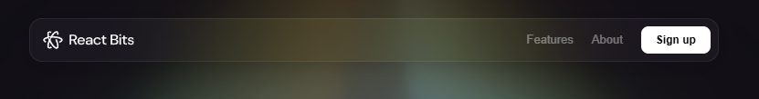
при нажатии на плашки сверху с разной информацией такая анимация:
npx shadcn@latest add @react-bits/GooeyNav-TS-CSS
usage:
import GooeyNav from './GooeyNav'

// update with your own items
const items = [
{ label: "Home", href: "#" },
{ label: "About", href: "#" },
{ label: "Contact", href: "#" },
];

<div style={{ height: '600px', position: 'relative' }}>
<GooeyNav
items={items}
particleCount={15}
particleDistances={[90, 10]}
particleR={100}
initialActiveIndex={0}
animationTime={600}
timeVariance={300}
colors={[1, 2, 3, 1, 2, 3, 1, 4]}
/>
</div>
code:
import React, { useRef, useEffect, useState } from 'react';
import './GooeyNav.css';

interface GooeyNavItem {
label: string;
href: string;
}

export interface GooeyNavProps {
items: GooeyNavItem[];
animationTime?: number;
particleCount?: number;
particleDistances?: [number, number];
particleR?: number;
timeVariance?: number;
colors?: number[];
initialActiveIndex?: number;
}

const GooeyNav: React.FC<GooeyNavProps> = ({
items,
animationTime = 600,
particleCount = 15,
particleDistances = [90, 10],
particleR = 100,
timeVariance = 300,
colors = [1, 2, 3, 1, 2, 3, 1, 4],
initialActiveIndex = 0
}) => {
const containerRef = useRef<HTMLDivElement>(null);
const navRef = useRef<HTMLUListElement>(null);
const filterRef = useRef<HTMLSpanElement>(null);
const textRef = useRef<HTMLSpanElement>(null);
const [activeIndex, setActiveIndex] = useState<number>(initialActiveIndex);

const noise = (n = 1) => n / 2 - Math.random() * n;

const getXY = (distance: number, pointIndex: number, totalPoints: number): [number, number] => {
const angle = ((360 + noise(8)) / totalPoints) * pointIndex * (Math.PI / 180);
return [distance * Math.cos(angle), distance * Math.sin(angle)];
};

const createParticle = (i: number, t: number, d: [number, number], r: number) => {
let rotate = noise(r / 10);
return {
start: getXY(d[0], particleCount - i, particleCount),
end: getXY(d[1] + noise(7), particleCount - i, particleCount),
time: t,
scale: 1 + noise(0.2),
color: colors[Math.floor(Math.random() * colors.length)],
rotate: rotate > 0 ? (rotate + r / 20) * 10 : (rotate - r / 20) * 10
};
};

const makeParticles = (element: HTMLElement) => {
const d: [number, number] = particleDistances;
const r = particleR;
const bubbleTime = animationTime * 2 + timeVariance;
element.style.setProperty('--time', `${bubbleTime}ms`);

for (let i = 0; i < particleCount; i++) {
const t = animationTime * 2 + noise(timeVariance * 2);
const p = createParticle(i, t, d, r);
element.classList.remove('active');

setTimeout(() => {
const particle = document.createElement('span');
const point = document.createElement('span');
particle.classList.add('particle');
particle.style.setProperty('--start-x', `${p.start[0]}px`);
particle.style.setProperty('--start-y', `${p.start[1]}px`);
particle.style.setProperty('--end-x', `${p.end[0]}px`);
particle.style.setProperty('--end-y', `${p.end[1]}px`);
particle.style.setProperty('--time', `${p.time}ms`);
particle.style.setProperty('--scale', `${p.scale}`);
particle.style.setProperty('--color', `var(--color-${p.color}, white)`);
particle.style.setProperty('--rotate', `${p.rotate}deg`);

point.classList.add('point');
particle.appendChild(point);
element.appendChild(particle);
requestAnimationFrame(() => {
element.classList.add('active');
});
setTimeout(() => {
try {
element.removeChild(particle);
} catch {
// Do nothing
}
}, t);
}, 30);
}
};

const updateEffectPosition = (element: HTMLElement) => {
if (!containerRef.current || !filterRef.current || !textRef.current) return;
const containerRect = containerRef.current.getBoundingClientRect();
const pos = element.getBoundingClientRect();

const styles = {
left: `${pos.x - containerRect.x}px`,
top: `${pos.y - containerRect.y}px`,
width: `${pos.width}px`,
height: `${pos.height}px`
};
Object.assign(filterRef.current.style, styles);
Object.assign(textRef.current.style, styles);
textRef.current.innerText = element.innerText;
};

const handleClick = (e: React.MouseEvent<HTMLAnchorElement>, index: number) => {
const liEl = e.currentTarget;
if (activeIndex === index) return;

setActiveIndex(index);
updateEffectPosition(liEl);

if (filterRef.current) {
const particles = filterRef.current.querySelectorAll('.particle');
particles.forEach(p => filterRef.current!.removeChild(p));
}

if (textRef.current) {
textRef.current.classList.remove('active');

void textRef.current.offsetWidth;
textRef.current.classList.add('active');
}

if (filterRef.current) {
makeParticles(filterRef.current);
}
};

const handleKeyDown = (e: React.KeyboardEvent<HTMLAnchorElement>, index: number) => {
if (e.key === 'Enter' || e.key === ' ') {
e.preventDefault();
const liEl = e.currentTarget.parentElement;
if (liEl) {
handleClick(
{
currentTarget: liEl
} as React.MouseEvent<HTMLAnchorElement>,
index
);
}
}
};

useEffect(() => {
if (!navRef.current || !containerRef.current) return;
const activeLi = navRef.current.querySelectorAll('li')[activeIndex] as HTMLElement;
if (activeLi) {
updateEffectPosition(activeLi);
textRef.current?.classList.add('active');
}

const resizeObserver = new ResizeObserver(() => {
const currentActiveLi = navRef.current?.querySelectorAll('li')[activeIndex] as HTMLElement;
if (currentActiveLi) {
updateEffectPosition(currentActiveLi);
}
});

resizeObserver.observe(containerRef.current);
return () => resizeObserver.disconnect();
}, [activeIndex]);

return (
<div className="gooey-nav-container" ref={containerRef}>
<nav>
<ul ref={navRef}>
{items.map((item, index) => (
<li key={index} className={activeIndex === index ? 'active' : ''}>
<a href={item.href} onClick={e => handleClick(e, index)} onKeyDown={e => handleKeyDown(e, index)}>
{item.label}
</a>
</li>
))}
</ul>
</nav>
<span className="effect filter" ref={filterRef} />
<span className="effect text" ref={textRef} />
</div>
);
};

export default GooeyNav;
css:
:root {
--linear-ease: linear(
0,
0.068,
0.19 2.7%,
0.804 8.1%,
1.037,
1.199 13.2%,
1.245,
1.27 15.8%,
1.274,
1.272 17.4%,
1.249 19.1%,
0.996 28%,
0.949,
0.928 33.3%,
0.926,
0.933 36.8%,
1.001 45.6%,
1.013,
1.019 50.8%,
1.018 54.4%,
1 63.1%,
0.995 68%,
1.001 85%,
1
);
}

.gooey-nav-container {
position: relative;
}

.gooey-nav-container nav {
display: flex;
position: relative;
transform: translate3d(0, 0, 0.01px);
}

.gooey-nav-container nav ul {
display: flex;
gap: 2em;
list-style: none;
padding: 0 1em;
margin: 0;
position: relative;
z-index: 3;
color: white;
text-shadow: 0 1px 1px hsl(205deg 30% 10% / 0.2);
}

.gooey-nav-container nav ul li {
border-radius: 100vw;
position: relative;
cursor: pointer;
transition:
background-color 0.3s ease,
color 0.3s ease,
box-shadow 0.3s ease;
box-shadow: 0 0 0.5px 1.5px transparent;
color: white;
}

.gooey-nav-container nav ul li a {
display: inline-block;
padding: 0.6em 1em;
}

.gooey-nav-container nav ul li:focus-within:has(:focus-visible) {
box-shadow: 0 0 0.5px 1.5px white;
}

.gooey-nav-container nav ul li::after {
content: '';
position: absolute;
inset: 0;
border-radius: 10px;
background: white;
opacity: 0;
transform: scale(0);
transition: all 0.3s ease;
z-index: -1;
}

.gooey-nav-container nav ul li.active {
color: black;
text-shadow: none;
}

.gooey-nav-container nav ul li.active::after {
opacity: 1;
transform: scale(1);
}

.gooey-nav-container .effect {
position: absolute;
left: 0;
top: 0;
width: 0;
height: 0;
opacity: 1;
pointer-events: none;
display: grid;
place-items: center;
z-index: 1;
}

.gooey-nav-container .effect.text {
color: white;
transition: color 0.3s ease;
}

.gooey-nav-container .effect.text.active {
color: black;
}

.gooey-nav-container .effect.filter {
filter: blur(7px) contrast(100) blur(0);
mix-blend-mode: lighten;
}

.gooey-nav-container .effect.filter::before {
content: '';
position: absolute;
inset: -75px;
z-index: -2;
background: black;
}

.gooey-nav-container .effect.filter::after {
content: '';
position: absolute;
inset: 0;
background: white;
transform: scale(0);
opacity: 0;
z-index: -1;
border-radius: 100vw;
}

.gooey-nav-container .effect.active::after {
animation: pill 0.3s ease both;
}

@keyframes pill {
to {
transform: scale(1);
opacity: 1;
}
}

.particle,
.point {
display: block;
opacity: 0;
width: 20px;
height: 20px;
border-radius: 100%;
transform-origin: center;
}

.particle {
--time: 5s;
position: absolute;
top: calc(50% - 8px);
left: calc(50% - 8px);
animation: particle calc(var(--time)) ease 1 -350ms;
}

.point {
background: var(--color);
opacity: 1;
animation: point calc(var(--time)) ease 1 -350ms;
}

@keyframes particle {
0% {
transform: rotate(0deg) translate(calc(var(--start-x)), calc(var(--start-y)));
opacity: 1;
animation-timing-function: cubic-bezier(0.55, 0, 1, 0.45);
}

70% {
transform: rotate(calc(var(--rotate) * 0.5)) translate(calc(var(--end-x) * 1.2), calc(var(--end-y) * 1.2));
opacity: 1;
animation-timing-function: ease;
}

85% {
transform: rotate(calc(var(--rotate) * 0.66)) translate(calc(var(--end-x)), calc(var(--end-y)));
opacity: 1;
}

100% {
transform: rotate(calc(var(--rotate) * 1.2)) translate(calc(var(--end-x) * 0.5), calc(var(--end-y) * 0.5));
opacity: 1;
}
}

@keyframes point {
0% {
transform: scale(0);
opacity: 0;
animation-timing-function: cubic-bezier(0.55, 0, 1, 0.45);
}

25% {
transform: scale(calc(var(--scale) * 0.25));
}

38% {
opacity: 1;
}

65% {
transform: scale(var(--scale));
opacity: 1;
animation-timing-function: ease;
}

85% {
transform: scale(var(--scale));
opacity: 1;
}

100% {
transform: scale(0);
opacity: 0;
}
}
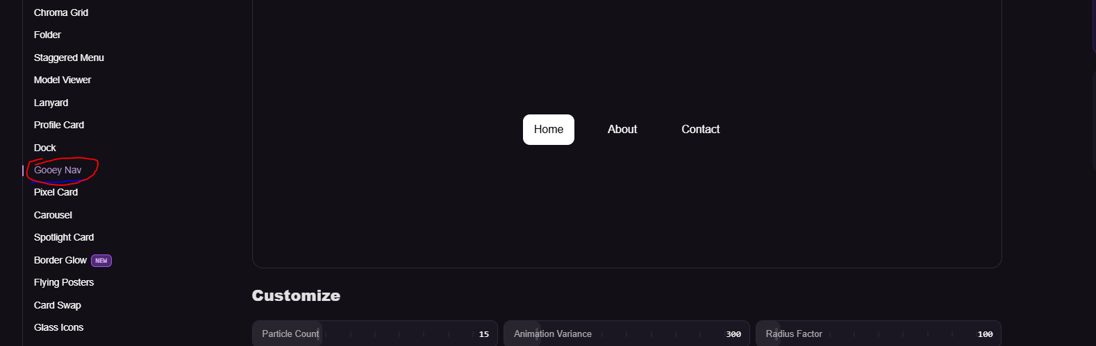

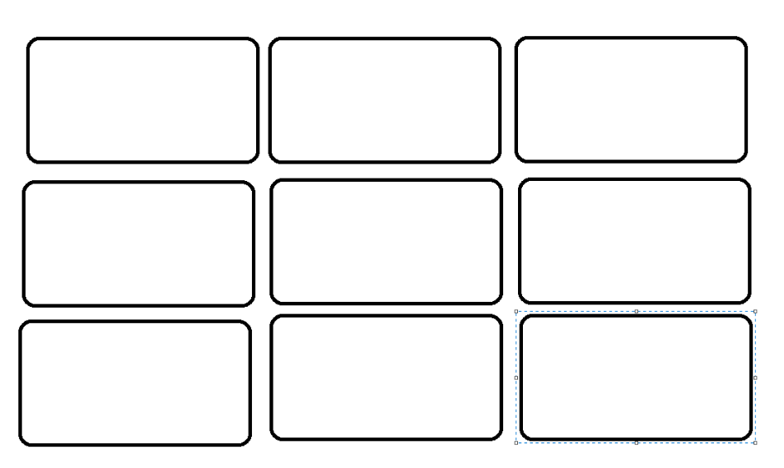
Вот в таком виде видосы для порфтофило.

Вот эту хуйню можно как фон засунуть куда нибудь:
npx shadcn@latest add @react-bits/Strands-TS-CSS
usage:
import Strands from './Strands';

<div style={{ width: '100%', height: '600px', position: 'relative' }}>
<Strands
colors={["#F97316","#7C3AED","#06B6D4"]}
count={3}
speed={0.5}
amplitude={1}
waviness={1}
thickness={0.7}
glow={2.6}
taper={3}
spread={1}
intensity={0.6}
saturation={2}
opacity={1}
scale={1.5}
glass={false}
refraction={1}
dispersion={1}
glassSize={1}
hueShift={0}
/>
</div>
code:
import { Renderer, Program, Mesh, Color, Triangle, RenderTarget } from 'ogl';
import { useEffect, useRef, CSSProperties } from 'react';

import './Strands.css';

const MAX_STRANDS = 12;
const MAX_COLORS = 8;

const VERT = `#version 300 es
in vec2 position;
void main() {
gl_Position = vec4(position, 0.0, 1.0);
}
`;

const FRAG = `#version 300 es
precision highp float;

uniform float uTime;
uniform vec2 uResolution;
uniform vec3 uColors[${MAX_COLORS}];
uniform int uColorCount;
uniform int uStrandCount;
uniform float uSpeed;
uniform float uAmplitude;
uniform float uWaviness;
uniform float uThickness;
uniform float uGlow;
uniform float uTaper;
uniform float uSpread;
uniform float uHueShift;
uniform float uIntensity;
uniform float uOpacity;
uniform float uScale;
uniform float uSaturation;

out vec4 fragColor;

const float PI = 3.14159265;

vec3 spectrum(float t) {
return 0.5 + 0.5 * cos(2.0 * PI * (t + vec3(0.00, 0.33, 0.67)));
}

vec3 samplePalette(float t) {
t = fract(t);
float scaled = t * float(uColorCount);
int idx = int(floor(scaled));
float blend = fract(scaled);
int nextIdx = idx + 1;
if (nextIdx >= uColorCount) nextIdx = 0;
return mix(uColors[idx], uColors[nextIdx], blend);
}

vec3 strandColor(float t) {
if (uColorCount > 0) return samplePalette(t);
return spectrum(t);
}

void main() {
vec2 uv = (gl_FragCoord.xy - 0.5 * uResolution) / uResolution.y;
uv /= max(uScale, 0.0001);

float e = 0.06 + uIntensity * 0.94;
float env = pow(max(cos(uv.x * PI * 1.3), 0.0), uTaper);

vec3 col = vec3(0.0);

for (int i = 0; i < ${MAX_STRANDS}; i++) {
if (i >= uStrandCount) break;

float fi = float(i);
float ph = fi * 1.7 * uSpread;
float freq = (2.0 + fi * 0.35) * uWaviness;
float spd = 1.4 + fi * 1.2;

float tt = uTime * uSpeed;
float w = sin(uv.x * freq + tt * spd + ph) * 0.60
+ sin(uv.x * freq * 1.1 - tt * spd * 0.7 + ph * 1.7) * 0.40;

float amp = (0.1 + 0.02 * e) * env * uAmplitude;
float y = w * amp;

float d = abs(uv.y - y);
float thick = (0.001 + 0.05 * e) * (0.35 + env) * uThickness;
float g = thick / (d + thick * 0.45);
g = g * g;

float h = fi / float(uStrandCount) + uv.x * 0.30 + uTime * 0.04 + uHueShift;
col += strandColor(h) * g * env;
}

col *= 0.45 + 0.7 * e;
col = 1.0 - exp(-col * uGlow);

float gray = dot(col, vec3(0.2126, 0.7152, 0.0722));
col = max(mix(vec3(gray), col, uSaturation), 0.0);

float lum = max(max(col.r, col.g), col.b);
float alpha = clamp(lum, 0.0, 1.0) * uOpacity;

fragColor = vec4(col * uOpacity, alpha);
}
`;

const GLASS_FRAG = `#version 300 es
precision highp float;

uniform sampler2D uScene;
uniform vec2 uResolution;
uniform float uRadius;
uniform float uRefraction;
uniform float uDispersion;

out vec4 fragColor;

vec2 toUv(vec2 p) {
return p * (uResolution.y / uResolution) + 0.5;
}

void main() {
vec2 p = (gl_FragCoord.xy - 0.5 * uResolution) / uResolution.y;
float d = length(p);
float r = uRadius;

float edge = fwidth(d) * 1.5;
float mask = 1.0 - smoothstep(r - edge, r + edge, d);
if (mask <= 0.0) {
fragColor = vec4(0.0);
return;
}

// sphere height: 0 at the rim, 1 at the center
float z = sqrt(max(r * r - d * d, 0.0)) / r;
float nd = d / r; // 0 at the center, 1 at the rim

// refraction is confined to a narrow band near the rim; the rest stays undistorted
vec2 dir = d > 0.0 ? p / d : vec2(0.0);
float lens = smoothstep(0.85, 1.0, nd) * pow(nd, 6.0);
vec2 offset = -dir * lens * uRefraction * 0.15;
vec2 disp = -dir * lens * uDispersion * 0.012;

vec3 light;
light.r = texture(uScene, toUv(p + offset - disp)).r;
light.g = texture(uScene, toUv(p + offset)).g;
light.b = texture(uScene, toUv(p + offset + disp)).b;

// neutral fresnel rim (no color tint so the glass stays clear)
float fres = pow(1.0 - z, 3.0);
vec3 rim = vec3(1.0) * fres * 0.18;

// specular highlight from the upper-left
vec2 lightDir = normalize(vec2(-0.55, 0.6));
float spec = pow(max(dot(p / max(r, 1e-4), lightDir), 0.0), 6.0);
spec *= smoothstep(r, r * 0.55, d);

vec3 emissive = light + rim + vec3(spec) * 0.4;
float emissiveA = clamp(max(max(emissive.r, emissive.g), emissive.b), 0.0, 1.0);

// almost clear glass body: only a faint neutral darkening, mostly near the rim
float bodyA = 0.05 + fres * 0.05;

// composite emissive light over the clear body (premultiplied)
float outA = emissiveA + bodyA * (1.0 - emissiveA);
vec3 outRGB = emissive;

outRGB *= mask;
outA *= mask;

fragColor = vec4(outRGB, outA);
}
`;

export interface StrandsProps {
colors?: string[];
count?: number;
speed?: number;
amplitude?: number;
waviness?: number;
thickness?: number;
glow?: number;
taper?: number;
spread?: number;
hueShift?: number;
intensity?: number;
saturation?: number;
opacity?: number;
scale?: number;
glass?: boolean;
refraction?: number;
dispersion?: number;
glassSize?: number;
className?: string;
style?: CSSProperties;
}

const buildPalette = (colors: string[]): number[][] => {
const filled = colors && colors.length ? colors : ['#ffffff'];
const padded: number[][] = [];
for (let i = 0; i < MAX_COLORS; i++) {
const hex = filled[i] ?? filled[filled.length - 1];
const c = new Color(hex);
padded.push([c.r, c.g, c.b]);
}
return padded;
};

export default function Strands({
colors = ['#FF4242', '#7C3AED', '#06B6D4', '#EAB308'],
count = 3,
speed = 0.5,
amplitude = 1,
waviness = 1,
thickness = 0.7,
glow = 2.6,
taper = 3,
spread = 1,
hueShift = 0,
intensity = 0.6,
saturation = 1.5,
opacity = 1,
scale = 1.5,
glass = false,
refraction = 1,
dispersion = 1,
glassSize = 1,
className = '',
style
}: StrandsProps) {
const propsRef = useRef<Required<Omit<StrandsProps, 'className' | 'style'>>>({
colors,
count,
speed,
amplitude,
waviness,
thickness,
glow,
taper,
spread,
hueShift,
intensity,
saturation,
opacity,
scale,
glass,
refraction,
dispersion,
glassSize
});
propsRef.current = {
colors,
count,
speed,
amplitude,
waviness,
thickness,
glow,
taper,
spread,
hueShift,
intensity,
saturation,
opacity,
scale,
glass,
refraction,
dispersion,
glassSize
};

const ctnDom = useRef<HTMLDivElement>(null);

useEffect(() => {
const ctn = ctnDom.current;
if (!ctn) return;

const renderer = new Renderer({
alpha: true,
premultipliedAlpha: true,
antialias: true
});
const gl = renderer.gl;
gl.clearColor(0, 0, 0, 0);
gl.enable(gl.BLEND);
gl.blendFunc(gl.ONE, gl.ONE_MINUS_SRC_ALPHA);
gl.canvas.style.backgroundColor = 'transparent';

const geometry = new Triangle(gl);
if (geometry.attributes.uv) {
delete geometry.attributes.uv;
}

const program = new Program(gl, {
vertex: VERT,
fragment: FRAG,
uniforms: {
uTime: { value: 0 },
uResolution: { value: [ctn.offsetWidth, ctn.offsetHeight] },
uColors: { value: buildPalette(propsRef.current.colors) },
uColorCount: { value: Math.min(propsRef.current.colors.length, MAX_COLORS) },
uStrandCount: { value: Math.min(propsRef.current.count, MAX_STRANDS) },
uSpeed: { value: speed },
uAmplitude: { value: amplitude },
uWaviness: { value: waviness },
uThickness: { value: thickness },
uGlow: { value: glow },
uTaper: { value: taper },
uSpread: { value: spread },
uHueShift: { value: hueShift },
uIntensity: { value: intensity },
uOpacity: { value: opacity },
uScale: { value: scale },
uSaturation: { value: saturation }
}
});

const mesh = new Mesh(gl, { geometry, program });

const renderTarget = new RenderTarget(gl, {
width: ctn.offsetWidth,
height: ctn.offsetHeight
});

const glassProgram = new Program(gl, {
vertex: VERT,
fragment: GLASS_FRAG,
uniforms: {
uScene: { value: renderTarget.texture },
uResolution: { value: [ctn.offsetWidth, ctn.offsetHeight] },
uRadius: { value: 0.46 * glassSize },
uRefraction: { value: refraction },
uDispersion: { value: dispersion }
}
});
const glassMesh = new Mesh(gl, { geometry, program: glassProgram });

ctn.appendChild(gl.canvas);

function resize() {
if (!ctn) return;
const width = ctn.offsetWidth;
const height = ctn.offsetHeight;
renderer.setSize(width, height);
program.uniforms.uResolution.value = [width, height];
renderTarget.setSize(width, height);
glassProgram.uniforms.uResolution.value = [width, height];
}
window.addEventListener('resize', resize);
resize();

let animateId = 0;
const update = (t: number) => {
animateId = requestAnimationFrame(update);
const current = propsRef.current;
program.uniforms.uTime.value = t * 0.001;
program.uniforms.uColors.value = buildPalette(current.colors);
program.uniforms.uColorCount.value = Math.min(current.colors.length, MAX_COLORS);
program.uniforms.uStrandCount.value = Math.min(Math.max(Math.round(current.count), 1), MAX_STRANDS);
program.uniforms.uSpeed.value = current.speed;
program.uniforms.uAmplitude.value = current.amplitude;
program.uniforms.uWaviness.value = current.waviness;
program.uniforms.uThickness.value = current.thickness;
program.uniforms.uGlow.value = current.glow;
program.uniforms.uTaper.value = current.taper;
program.uniforms.uSpread.value = current.spread;
program.uniforms.uHueShift.value = current.hueShift;
program.uniforms.uIntensity.value = current.intensity;
program.uniforms.uOpacity.value = current.opacity;
program.uniforms.uScale.value = current.scale;
program.uniforms.uSaturation.value = current.saturation;

if (current.glass) {
renderer.render({ scene: mesh, target: renderTarget });
glassProgram.uniforms.uScene.value = renderTarget.texture;
glassProgram.uniforms.uRefraction.value = current.refraction;
glassProgram.uniforms.uDispersion.value = current.dispersion;
glassProgram.uniforms.uRadius.value = 0.46 * current.glassSize;
renderer.render({ scene: glassMesh });
} else {
renderer.render({ scene: mesh });
}
};
animateId = requestAnimationFrame(update);

return () => {
cancelAnimationFrame(animateId);
window.removeEventListener('resize', resize);
if (ctn && gl.canvas.parentNode === ctn) {
ctn.removeChild(gl.canvas);
}
gl.getExtension('WEBGL_lose_context')?.loseContext();
};
// eslint-disable-next-line react-hooks/exhaustive-deps
}, []);

return <div ref={ctnDom} className={`strands-container ${className}`} style={style} />;
}
css:
.strands-container {
position: relative;
width: 100%;
height: 100%;
background: transparent;
}

.strands-container canvas {
display: block;
width: 100%;
height: 100%;
}
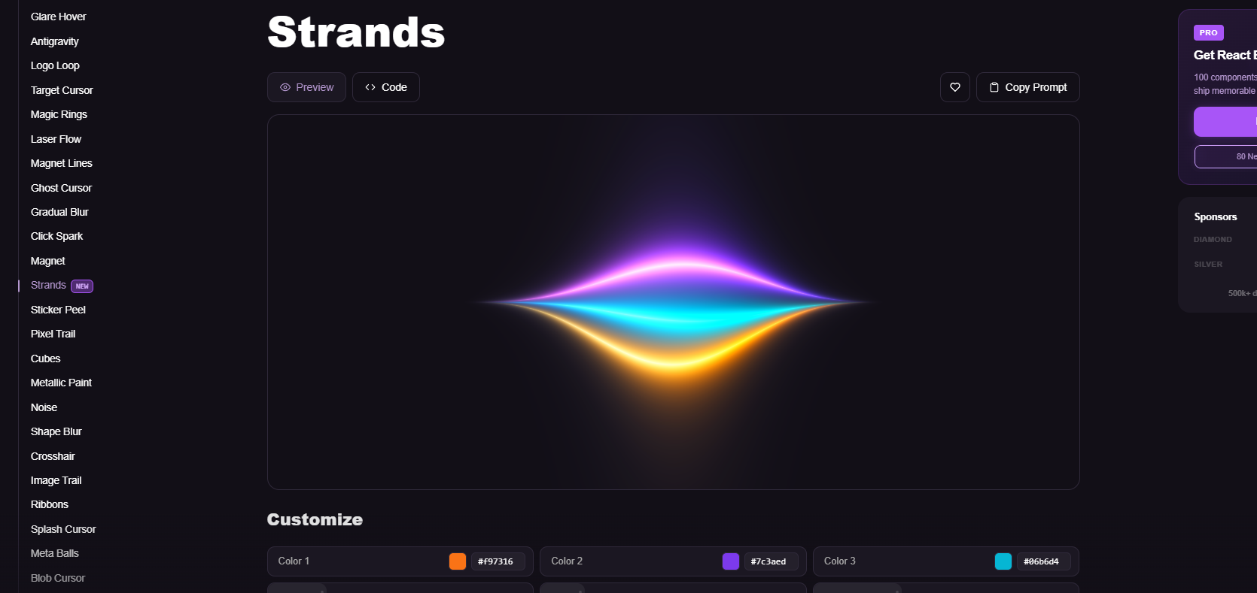
В остальных местах в основном фон будет вот такой:
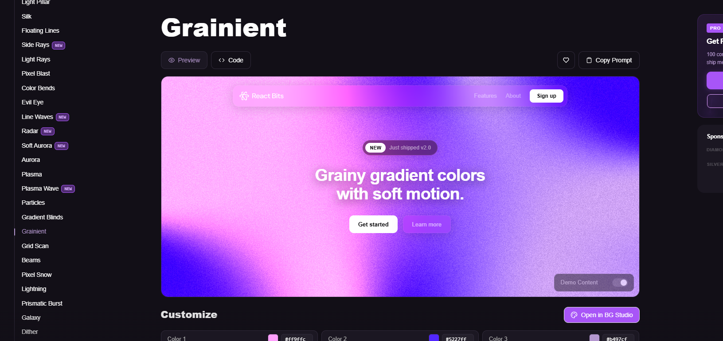
Текст можно оформить в таком виде:
npx shadcn@latest add @react-bits/GradientText-TS-CSS
usage:
import GradientText from './GradientText'

// For a smoother animation, the gradient should start and end with the same color

<GradientText
colors={["#5227FF","#FF9FFC","#B497CF"]}
animationSpeed={8}
showBorder={false}
className="custom-class"
>
Add a splash of color!
</GradientText>
code:
import { useState, useCallback, useEffect, useRef, ReactNode } from 'react';
import { motion, useMotionValue, useAnimationFrame, useTransform } from 'motion/react';
import './GradientText.css';

interface GradientTextProps {
children: ReactNode;
className?: string;
colors?: string[];
animationSpeed?: number;
showBorder?: boolean;
direction?: 'horizontal' | 'vertical' | 'diagonal';
pauseOnHover?: boolean;
yoyo?: boolean;
}

export default function GradientText({
children,
className = '',
colors = ['#5227FF', '#FF9FFC', '#B497CF'],
animationSpeed = 8,
showBorder = false,
direction = 'horizontal',
pauseOnHover = false,
yoyo = true
}: GradientTextProps) {
const [isPaused, setIsPaused] = useState(false);
const progress = useMotionValue(0);
const elapsedRef = useRef(0);
const lastTimeRef = useRef<number | null>(null);

const animationDuration = animationSpeed * 1000;

useAnimationFrame(time => {
if (isPaused) {
lastTimeRef.current = null;
return;
}

if (lastTimeRef.current === null) {
lastTimeRef.current = time;
return;
}

const deltaTime = time - lastTimeRef.current;
lastTimeRef.current = time;
elapsedRef.current += deltaTime;

if (yoyo) {
const fullCycle = animationDuration * 2;
const cycleTime = elapsedRef.current % fullCycle;

if (cycleTime < animationDuration) {
progress.set((cycleTime / animationDuration) * 100);
} else {
progress.set(100 - ((cycleTime - animationDuration) / animationDuration) * 100);
}
} else {
// Continuously increase position for seamless looping
progress.set((elapsedRef.current / animationDuration) * 100);
}
});

useEffect(() => {
elapsedRef.current = 0;
progress.set(0);
}, [animationSpeed, yoyo]);

const backgroundPosition = useTransform(progress, p => {
if (direction === 'horizontal') {
return `${p}% 50%`;
} else if (direction === 'vertical') {
return `50% ${p}%`;
} else {
// For diagonal, move only horizontally to avoid interference patterns
return `${p}% 50%`;
}
});

const handleMouseEnter = useCallback(() => {
if (pauseOnHover) setIsPaused(true);
}, [pauseOnHover]);

const handleMouseLeave = useCallback(() => {
if (pauseOnHover) setIsPaused(false);
}, [pauseOnHover]);

const gradientAngle =
direction === 'horizontal' ? 'to right' : direction === 'vertical' ? 'to bottom' : 'to bottom right';
// Duplicate first color at the end for seamless looping
const gradientColors = [...colors, colors[0]].join(', ');

const gradientStyle = {
backgroundImage: `linear-gradient(${gradientAngle}, ${gradientColors})`,
backgroundSize: direction === 'horizontal' ? '300% 100%' : direction === 'vertical' ? '100% 300%' : '300% 300%',
backgroundRepeat: 'repeat'
};

return (
<motion.div
className={`animated-gradient-text ${showBorder ? 'with-border' : ''} ${className}`}
onMouseEnter={handleMouseEnter}
onMouseLeave={handleMouseLeave}
>
{showBorder && <motion.div className="gradient-overlay" style={{ ...gradientStyle, backgroundPosition }} />}
<motion.div className="text-content" style={{ ...gradientStyle, backgroundPosition }}>
{children}
</motion.div>
</motion.div>
);
}
css:
.animated-gradient-text {
position: relative;
margin: 0 auto;
display: flex;
max-width: fit-content;
flex-direction: row;
align-items: center;
justify-content: center;
border-radius: 1.25rem;
font-weight: 500;
backdrop-filter: blur(10px);
transition: box-shadow 0.5s ease-out;
overflow: hidden;
cursor: pointer;
}

.animated-gradient-text.with-border {
padding: 0.35rem 0.75rem;
}

.gradient-overlay {
position: absolute;
top: 0;
left: 0;
right: 0;
bottom: 0;
border-radius: inherit;
z-index: 0;
pointer-events: none;
}

.gradient-overlay::before {
content: '';
position: absolute;
left: 0;
top: 0;
border-radius: inherit;
width: calc(100% - 2px);
height: calc(100% - 2px);
left: 50%;
top: 50%;
transform: translate(-50%, -50%);
background-color: #120F17;
z-index: -1;
}

.text-content {
display: inline-block;
position: relative;
z-index: 2;
background-clip: text;
-webkit-background-clip: text;
color: transparent;
}
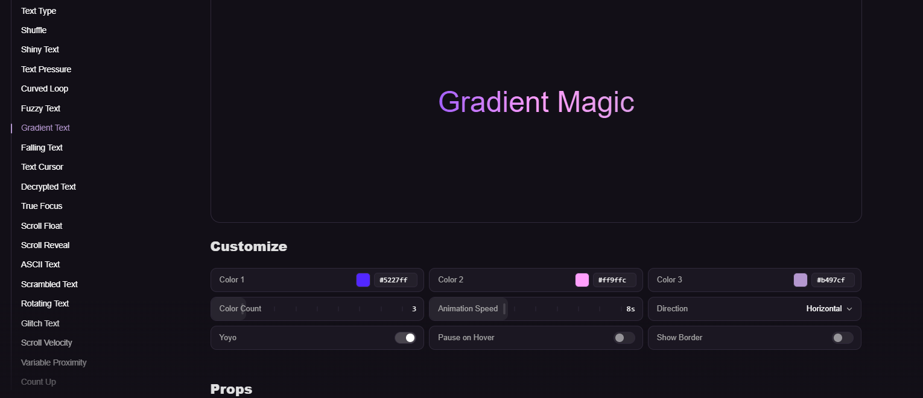

Доп видосы можно оформить в таком виде ( будет где-нибудь внизу):

npx shadcn@latest add @react-bits/InfiniteMenu-TS-CSS
usage:
import InfiniteMenu from './InfiniteMenu'

const items = [
{
image: 'https://picsum.photos/300/300?grayscale',
link: 'https://google.com/',
title: 'Item 1',
description: 'This is pretty cool, right?'
},
{
image: 'https://picsum.photos/400/400?grayscale',
link: 'https://google.com/',
title: 'Item 2',
description: 'This is pretty cool, right?'
},
{
image: 'https://picsum.photos/500/500?grayscale',
link: 'https://google.com/',
title: 'Item 3',
description: 'This is pretty cool, right?'
},
{
image: 'https://picsum.photos/600/600?grayscale',
link: 'https://google.com/',
title: 'Item 4',
description: 'This is pretty cool, right?'
}
];

<div style={{ height: '600px', position: 'relative' }}>
<InfiniteMenu items={items}
scale={1}
/>
</div>
code:
import { FC, useRef, useState, useEffect, MutableRefObject } from 'react';
import { mat4, quat, vec2, vec3 } from 'gl-matrix';
import './InfiniteMenu.css';

const discVertShaderSource = `#version 300 es

uniform mat4 uWorldMatrix;
uniform mat4 uViewMatrix;
uniform mat4 uProjectionMatrix;
uniform vec3 uCameraPosition;
uniform vec4 uRotationAxisVelocity;

in vec3 aModelPosition;
in vec3 aModelNormal;
in vec2 aModelUvs;
in mat4 aInstanceMatrix;

out vec2 vUvs;
out float vAlpha;
flat out int vInstanceId;

#define PI 3.141593

void main() {
vec4 worldPosition = uWorldMatrix * aInstanceMatrix * vec4(aModelPosition, 1.);

vec3 centerPos = (uWorldMatrix * aInstanceMatrix * vec4(0., 0., 0., 1.)).xyz;
float radius = length(centerPos.xyz);

if (gl_VertexID > 0) {
vec3 rotationAxis = uRotationAxisVelocity.xyz;
float rotationVelocity = min(.15, uRotationAxisVelocity.w * 15.);
vec3 stretchDir = normalize(cross(centerPos, rotationAxis));
vec3 relativeVertexPos = normalize(worldPosition.xyz - centerPos);
float strength = dot(stretchDir, relativeVertexPos);
float invAbsStrength = min(0., abs(strength) - 1.);
strength = rotationVelocity * sign(strength) * abs(invAbsStrength * invAbsStrength * invAbsStrength + 1.);
worldPosition.xyz += stretchDir * strength;
}

worldPosition.xyz = radius * normalize(worldPosition.xyz);

gl_Position = uProjectionMatrix * uViewMatrix * worldPosition;

vAlpha = smoothstep(0.5, 1., normalize(worldPosition.xyz).z) * .9 + .1;
vUvs = aModelUvs;
vInstanceId = gl_InstanceID;
}
`;

const discFragShaderSource = `#version 300 es
precision highp float;

uniform sampler2D uTex;
uniform int uItemCount;
uniform int uAtlasSize;

out vec4 outColor;

in vec2 vUvs;
in float vAlpha;
flat in int vInstanceId;

void main() {
int itemIndex = vInstanceId % uItemCount;
int cellsPerRow = uAtlasSize;
int cellX = itemIndex % cellsPerRow;
int cellY = itemIndex / cellsPerRow;
vec2 cellSize = vec2(1.0) / vec2(float(cellsPerRow));
vec2 cellOffset = vec2(float(cellX), float(cellY)) * cellSize;

ivec2 texSize = textureSize(uTex, 0);
float imageAspect = float(texSize.x) / float(texSize.y);
float containerAspect = 1.0;

float scale = max(imageAspect / containerAspect,
containerAspect / imageAspect);

vec2 st = vec2(vUvs.x, 1.0 - vUvs.y);
st = (st - 0.5) * scale + 0.5;

st = clamp(st, 0.0, 1.0);

st = st * cellSize + cellOffset;

outColor = texture(uTex, st);
outColor.a *= vAlpha;
}
`;

class Face {
public a: number;
public b: number;
public c: number;

constructor(a: number, b: number, c: number) {
this.a = a;
this.b = b;
this.c = c;
}
}

class Vertex {
public position: vec3;
public normal: vec3;
public uv: vec2;

constructor(x: number, y: number, z: number) {
this.position = vec3.fromValues(x, y, z);
this.normal = vec3.create();
this.uv = vec2.create();
}
}

class Geometry {
public vertices: Vertex[];
public faces: Face[];

constructor() {
this.vertices = [];
this.faces = [];
}

public addVertex(...args: number[]): this {
for (let i = 0; i < args.length; i += 3) {
this.vertices.push(new Vertex(args[i], args[i + 1], args[i + 2]));
}
return this;
}

public addFace(...args: number[]): this {
for (let i = 0; i < args.length; i += 3) {
this.faces.push(new Face(args[i], args[i + 1], args[i + 2]));
}
return this;
}

public get lastVertex(): Vertex {
return this.vertices[this.vertices.length - 1];
}

public subdivide(divisions = 1): this {
const midPointCache: Record<string, number> = {};
let f = this.faces;

for (let div = 0; div < divisions; ++div) {
const newFaces = new Array<Face>(f.length * 4);

f.forEach((face, ndx) => {
const mAB = this.getMidPoint(face.a, face.b, midPointCache);
const mBC = this.getMidPoint(face.b, face.c, midPointCache);
const mCA = this.getMidPoint(face.c, face.a, midPointCache);

const i = ndx * 4;
newFaces[i + 0] = new Face(face.a, mAB, mCA);
newFaces[i + 1] = new Face(face.b, mBC, mAB);
newFaces[i + 2] = new Face(face.c, mCA, mBC);
newFaces[i + 3] = new Face(mAB, mBC, mCA);
});

f = newFaces;
}

this.faces = f;
return this;
}

public spherize(radius = 1): this {
this.vertices.forEach(vertex => {
vec3.normalize(vertex.normal, vertex.position);
vec3.scale(vertex.position, vertex.normal, radius);
});
return this;
}

public get data(): {
vertices: Float32Array;
indices: Uint16Array;
normals: Float32Array;
uvs: Float32Array;
} {
return {
vertices: this.vertexData,
indices: this.indexData,
normals: this.normalData,
uvs: this.uvData
};
}

public get vertexData(): Float32Array {
return new Float32Array(this.vertices.flatMap(v => Array.from(v.position)));
}

public get normalData(): Float32Array {
return new Float32Array(this.vertices.flatMap(v => Array.from(v.normal)));
}

public get uvData(): Float32Array {
return new Float32Array(this.vertices.flatMap(v => Array.from(v.uv)));
}

public get indexData(): Uint16Array {
return new Uint16Array(this.faces.flatMap(f => [f.a, f.b, f.c]));
}

public getMidPoint(ndxA: number, ndxB: number, cache: Record<string, number>): number {
const cacheKey = ndxA < ndxB ? `k_${ndxB}_${ndxA}` : `k_${ndxA}_${ndxB}`;
if (Object.prototype.hasOwnProperty.call(cache, cacheKey)) {
return cache[cacheKey];
}
const a = this.vertices[ndxA].position;
const b = this.vertices[ndxB].position;
const ndx = this.vertices.length;
cache[cacheKey] = ndx;
this.addVertex((a[0] + b[0]) * 0.5, (a[1] + b[1]) * 0.5, (a[2] + b[2]) * 0.5);
return ndx;
}
}

class IcosahedronGeometry extends Geometry {
constructor() {
super();
const t = Math.sqrt(5) * 0.5 + 0.5;
this.addVertex(
-1,
t,
0,
1,
t,
0,
-1,
-t,
0,
1,
-t,
0,
0,
-1,
t,
0,
1,
t,
0,
-1,
-t,
0,
1,
-t,
t,
0,
-1,
t,
0,
1,
-t,
0,
-1,
-t,
0,
1
).addFace(
0,
11,
5,
0,
5,
1,
0,
1,
7,
0,
7,
10,
0,
10,
11,
1,
5,
9,
5,
11,
4,
11,
10,
2,
10,
7,
6,
7,
1,
8,
3,
9,
4,
3,
4,
2,
3,
2,
6,
3,
6,
8,
3,
8,
9,
4,
9,
5,
2,
4,
11,
6,
2,
10,
8,
6,
7,
9,
8,
1
);
}
}

class DiscGeometry extends Geometry {
constructor(steps = 4, radius = 1) {
super();
const safeSteps = Math.max(4, steps);
const alpha = (2 * Math.PI) / safeSteps;

this.addVertex(0, 0, 0);
this.lastVertex.uv[0] = 0.5;
this.lastVertex.uv[1] = 0.5;

for (let i = 0; i < safeSteps; ++i) {
const x = Math.cos(alpha * i);
const y = Math.sin(alpha * i);
this.addVertex(radius * x, radius * y, 0);
this.lastVertex.uv[0] = x * 0.5 + 0.5;
this.lastVertex.uv[1] = y * 0.5 + 0.5;

if (i > 0) {
this.addFace(0, i, i + 1);
}
}
this.addFace(0, safeSteps, 1);
}
}

function createShader(gl: WebGL2RenderingContext, type: number, source: string): WebGLShader | null {
const shader = gl.createShader(type);
if (!shader) return null;
gl.shaderSource(shader, source);
gl.compileShader(shader);
const success = gl.getShaderParameter(shader, gl.COMPILE_STATUS);

if (success) {
return shader;
}

console.error(gl.getShaderInfoLog(shader));
gl.deleteShader(shader);
return null;
}

function createProgram(
gl: WebGL2RenderingContext,
shaderSources: [string, string],
transformFeedbackVaryings?: string[] | null,
attribLocations?: Record<string, number>
): WebGLProgram | null {
const program = gl.createProgram();
if (!program) return null;

[gl.VERTEX_SHADER, gl.FRAGMENT_SHADER].forEach((type, ndx) => {
const shader = createShader(gl, type, shaderSources[ndx]);
if (shader) {
gl.attachShader(program, shader);
}
});

if (transformFeedbackVaryings) {
gl.transformFeedbackVaryings(program, transformFeedbackVaryings, gl.SEPARATE_ATTRIBS);
}

if (attribLocations) {
for (const attrib in attribLocations) {
if (Object.prototype.hasOwnProperty.call(attribLocations, attrib)) {
gl.bindAttribLocation(program, attribLocations[attrib], attrib);
}
}
}

gl.linkProgram(program);
const success = gl.getProgramParameter(program, gl.LINK_STATUS);

if (success) {
return program;
}

console.error(gl.getProgramInfoLog(program));
gl.deleteProgram(program);
return null;
}

function makeVertexArray(
gl: WebGL2RenderingContext,
bufLocNumElmPairs: Array<[WebGLBuffer, number, number]>,
indices?: Uint16Array
): WebGLVertexArrayObject | null {
const va = gl.createVertexArray();
if (!va) return null;

gl.bindVertexArray(va);

for (const [buffer, loc, numElem] of bufLocNumElmPairs) {
if (loc === -1) continue;
gl.bindBuffer(gl.ARRAY_BUFFER, buffer);
gl.enableVertexAttribArray(loc);
gl.vertexAttribPointer(loc, numElem, gl.FLOAT, false, 0, 0);
}

if (indices) {
const indexBuffer = gl.createBuffer();
if (indexBuffer) {
gl.bindBuffer(gl.ELEMENT_ARRAY_BUFFER, indexBuffer);
gl.bufferData(gl.ELEMENT_ARRAY_BUFFER, indices, gl.STATIC_DRAW);
}
}

gl.bindVertexArray(null);
return va;
}

function resizeCanvasToDisplaySize(canvas: HTMLCanvasElement): boolean {
const dpr = Math.min(2, window.devicePixelRatio || 1);
const displayWidth = Math.round(canvas.clientWidth * dpr);
const displayHeight = Math.round(canvas.clientHeight * dpr);
const needResize = canvas.width !== displayWidth || canvas.height !== displayHeight;
if (needResize) {
canvas.width = displayWidth;
canvas.height = displayHeight;
}
return needResize;
}

function makeBuffer(gl: WebGL2RenderingContext, sizeOrData: number | ArrayBufferView, usage: number): WebGLBuffer {
const buf = gl.createBuffer();
if (!buf) {
throw new Error('Failed to create WebGL buffer.');
}
gl.bindBuffer(gl.ARRAY_BUFFER, buf);

if (typeof sizeOrData === 'number') {
gl.bufferData(gl.ARRAY_BUFFER, sizeOrData, usage);
} else {
gl.bufferData(gl.ARRAY_BUFFER, sizeOrData, usage);
}

gl.bindBuffer(gl.ARRAY_BUFFER, null);
return buf;
}

function createAndSetupTexture(
gl: WebGL2RenderingContext,
minFilter: number,
magFilter: number,
wrapS: number,
wrapT: number
): WebGLTexture {
const texture = gl.createTexture();
if (!texture) {
throw new Error('Failed to create WebGL texture.');
}
gl.bindTexture(gl.TEXTURE_2D, texture);
gl.texParameteri(gl.TEXTURE_2D, gl.TEXTURE_WRAP_S, wrapS);
gl.texParameteri(gl.TEXTURE_2D, gl.TEXTURE_WRAP_T, wrapT);
gl.texParameteri(gl.TEXTURE_2D, gl.TEXTURE_MIN_FILTER, minFilter);
gl.texParameteri(gl.TEXTURE_2D, gl.TEXTURE_MAG_FILTER, magFilter);
return texture;
}

type UpdateCallback = (deltaTime: number) => void;

class ArcballControl {
private canvas: HTMLCanvasElement;
private updateCallback: UpdateCallback;

public isPointerDown = false;
public orientation = quat.create();
public pointerRotation = quat.create();
public rotationVelocity = 0;
public rotationAxis = vec3.fromValues(1, 0, 0);

public snapDirection = vec3.fromValues(0, 0, -1);
public snapTargetDirection: vec3 | null = null;

private pointerPos = vec2.create();
private previousPointerPos = vec2.create();
private _rotationVelocity = 0;
private _combinedQuat = quat.create();

private readonly EPSILON = 0.1;
private readonly IDENTITY_QUAT = quat.create();

constructor(canvas: HTMLCanvasElement, updateCallback?: UpdateCallback) {
this.canvas = canvas;
this.updateCallback = updateCallback || (() => undefined);

canvas.addEventListener('pointerdown', (e: PointerEvent) => {
vec2.set(this.pointerPos, e.clientX, e.clientY);
vec2.copy(this.previousPointerPos, this.pointerPos);
this.isPointerDown = true;
});
canvas.addEventListener('pointerup', () => {
this.isPointerDown = false;
});
canvas.addEventListener('pointerleave', () => {
this.isPointerDown = false;
});
canvas.addEventListener('pointermove', (e: PointerEvent) => {
if (this.isPointerDown) {
vec2.set(this.pointerPos, e.clientX, e.clientY);
}
});

canvas.style.touchAction = 'none';
}

public update(deltaTime: number, targetFrameDuration = 16): void {
const timeScale = deltaTime / targetFrameDuration + 0.00001;
let angleFactor = timeScale;
const snapRotation = quat.create();

if (this.isPointerDown) {
const INTENSITY = 0.3 * timeScale;
const ANGLE_AMPLIFICATION = 5 / timeScale;

const midPointerPos = vec2.sub(vec2.create(), this.pointerPos, this.previousPointerPos);
vec2.scale(midPointerPos, midPointerPos, INTENSITY);

if (vec2.sqrLen(midPointerPos) > this.EPSILON) {
vec2.add(midPointerPos, this.previousPointerPos, midPointerPos);

const p = this.project(midPointerPos);
const q = this.project(this.previousPointerPos);
const a = vec3.normalize(vec3.create(), p);
const b = vec3.normalize(vec3.create(), q);

vec2.copy(this.previousPointerPos, midPointerPos);

angleFactor *= ANGLE_AMPLIFICATION;

this.quatFromVectors(a, b, this.pointerRotation, angleFactor);
} else {
quat.slerp(this.pointerRotation, this.pointerRotation, this.IDENTITY_QUAT, INTENSITY);
}
} else {
const INTENSITY = 0.1 * timeScale;
quat.slerp(this.pointerRotation, this.pointerRotation, this.IDENTITY_QUAT, INTENSITY);

if (this.snapTargetDirection) {
const SNAPPING_INTENSITY = 0.2;
const a = this.snapTargetDirection;
const b = this.snapDirection;
const sqrDist = vec3.squaredDistance(a, b);
const distanceFactor = Math.max(0.1, 1 - sqrDist * 10);
angleFactor *= SNAPPING_INTENSITY * distanceFactor;
this.quatFromVectors(a, b, snapRotation, angleFactor);
}
}

const combinedQuat = quat.multiply(quat.create(), snapRotation, this.pointerRotation);
this.orientation = quat.multiply(quat.create(), combinedQuat, this.orientation);
quat.normalize(this.orientation, this.orientation);

const RA_INTENSITY = 0.8 * timeScale;
quat.slerp(this._combinedQuat, this._combinedQuat, combinedQuat, RA_INTENSITY);
quat.normalize(this._combinedQuat, this._combinedQuat);

const rad = Math.acos(this._combinedQuat[3]) * 2.0;
const s = Math.sin(rad / 2.0);
let rv = 0;
if (s > 0.000001) {
rv = rad / (2 * Math.PI);
this.rotationAxis[0] = this._combinedQuat[0] / s;
this.rotationAxis[1] = this._combinedQuat[1] / s;
this.rotationAxis[2] = this._combinedQuat[2] / s;
}

const RV_INTENSITY = 0.5 * timeScale;
this._rotationVelocity += (rv - this._rotationVelocity) * RV_INTENSITY;
this.rotationVelocity = this._rotationVelocity / timeScale;

this.updateCallback(deltaTime);
}

private quatFromVectors(a: vec3, b: vec3, out: quat, angleFactor = 1): { q: quat; axis: vec3; angle: number } {
const axis = vec3.cross(vec3.create(), a, b);
vec3.normalize(axis, axis);
const d = Math.max(-1, Math.min(1, vec3.dot(a, b)));
const angle = Math.acos(d) * angleFactor;
quat.setAxisAngle(out, axis, angle);
return { q: out, axis, angle };
}

private project(pos: vec2): vec3 {
const r = 2;
const w = this.canvas.clientWidth;
const h = this.canvas.clientHeight;
const s = Math.max(w, h) - 1;

const x = (2 * pos[0] - w - 1) / s;
const y = (2 * pos[1] - h - 1) / s;
let z = 0;
const xySq = x * x + y * y;
const rSq = r * r;

if (xySq <= rSq / 2.0) {
z = Math.sqrt(rSq - xySq);
} else {
z = rSq / Math.sqrt(xySq);
}
return vec3.fromValues(-x, y, z);
}
}

interface MenuItem {
image: string;
link: string;
title: string;
description: string;
}

type ActiveItemCallback = (index: number) => void;
type MovementChangeCallback = (isMoving: boolean) => void;
type InitCallback = (instance: InfiniteGridMenu) => void;

interface Camera {
matrix: mat4;
near: number;
far: number;
fov: number;
aspect: number;
position: vec3;
up: vec3;
matrices: {
view: mat4;
projection: mat4;
inversProjection: mat4;
};
}

class InfiniteGridMenu {
private gl: WebGL2RenderingContext | null = null;
private discProgram: WebGLProgram | null = null;
private discVAO: WebGLVertexArrayObject | null = null;
private discBuffers!: {
vertices: Float32Array;
indices: Uint16Array;
normals: Float32Array;
uvs: Float32Array;
};
private icoGeo!: IcosahedronGeometry;
private discGeo!: DiscGeometry;
private worldMatrix = mat4.create();
private tex: WebGLTexture | null = null;
private control!: ArcballControl;

private discLocations!: {
aModelPosition: number;
aModelUvs: number;
aInstanceMatrix: number;
uWorldMatrix: WebGLUniformLocation | null;
uViewMatrix: WebGLUniformLocation | null;
uProjectionMatrix: WebGLUniformLocation | null;
uCameraPosition: WebGLUniformLocation | null;
uScaleFactor: WebGLUniformLocation | null;
uRotationAxisVelocity: WebGLUniformLocation | null;
uTex: WebGLUniformLocation | null;
uFrames: WebGLUniformLocation | null;
uItemCount: WebGLUniformLocation | null;
uAtlasSize: WebGLUniformLocation | null;
};

private viewportSize = vec2.create();
private drawBufferSize = vec2.create();

private discInstances!: {
matricesArray: Float32Array;
matrices: Float32Array[];
buffer: WebGLBuffer | null;
};

private instancePositions: vec3[] = [];
private DISC_INSTANCE_COUNT = 0;
private atlasSize = 1;

private _time = 0;
private _deltaTime = 0;
private _deltaFrames = 0;
private _frames = 0;

private movementActive = false;

private TARGET_FRAME_DURATION = 1000 / 60;
private SPHERE_RADIUS = 2;

public camera: Camera = {
matrix: mat4.create(),
near: 0.1,
far: 40,
fov: Math.PI / 4,
aspect: 1,
position: vec3.fromValues(0, 0, 3),
up: vec3.fromValues(0, 1, 0),
matrices: {
view: mat4.create(),
projection: mat4.create(),
inversProjection: mat4.create()
}
};

public smoothRotationVelocity = 0;
public scaleFactor = 1.0;

constructor(
private canvas: HTMLCanvasElement,
private items: MenuItem[],
private onActiveItemChange: ActiveItemCallback,
private onMovementChange: MovementChangeCallback,
onInit?: InitCallback,
scale: number = 1.0
) {
this.scaleFactor = scale;
this.camera.position[2] = 3 * scale;
this.init(onInit);
}

public resize(): void {
const needsResize = resizeCanvasToDisplaySize(this.canvas);
if (!this.gl) return;
if (needsResize) {
this.gl.viewport(0, 0, this.gl.drawingBufferWidth, this.gl.drawingBufferHeight);
}
this.updateProjectionMatrix();
}

public run(time = 0): void {
this._deltaTime = Math.min(32, time - this._time);
this._time = time;
this._deltaFrames = this._deltaTime / this.TARGET_FRAME_DURATION;
this._frames += this._deltaFrames;

this.animate(this._deltaTime);
this.render();

requestAnimationFrame(t => this.run(t));
}

private init(onInit?: InitCallback): void {
const gl = this.canvas.getContext('webgl2', {
antialias: true,
alpha: false
});
if (!gl) {
throw new Error('No WebGL 2 context!');
}
this.gl = gl;

vec2.set(this.viewportSize, this.canvas.clientWidth, this.canvas.clientHeight);
vec2.clone(this.drawBufferSize);

this.discProgram = createProgram(gl, [discVertShaderSource, discFragShaderSource], null, {
aModelPosition: 0,
aModelNormal: 1,
aModelUvs: 2,
aInstanceMatrix: 3
});

this.discLocations = {
aModelPosition: gl.getAttribLocation(this.discProgram!, 'aModelPosition'),
aModelUvs: gl.getAttribLocation(this.discProgram!, 'aModelUvs'),
aInstanceMatrix: gl.getAttribLocation(this.discProgram!, 'aInstanceMatrix'),
uWorldMatrix: gl.getUniformLocation(this.discProgram!, 'uWorldMatrix'),
uViewMatrix: gl.getUniformLocation(this.discProgram!, 'uViewMatrix'),
uProjectionMatrix: gl.getUniformLocation(this.discProgram!, 'uProjectionMatrix'),
uCameraPosition: gl.getUniformLocation(this.discProgram!, 'uCameraPosition'),
uScaleFactor: gl.getUniformLocation(this.discProgram!, 'uScaleFactor'),
uRotationAxisVelocity: gl.getUniformLocation(this.discProgram!, 'uRotationAxisVelocity'),
uTex: gl.getUniformLocation(this.discProgram!, 'uTex'),
uFrames: gl.getUniformLocation(this.discProgram!, 'uFrames'),
uItemCount: gl.getUniformLocation(this.discProgram!, 'uItemCount'),
uAtlasSize: gl.getUniformLocation(this.discProgram!, 'uAtlasSize')
};

this.discGeo = new DiscGeometry(56, 1);
this.discBuffers = this.discGeo.data;
this.discVAO = makeVertexArray(
gl,
[
[makeBuffer(gl, this.discBuffers.vertices, gl.STATIC_DRAW), this.discLocations.aModelPosition, 3],
[makeBuffer(gl, this.discBuffers.uvs, gl.STATIC_DRAW), this.discLocations.aModelUvs, 2]
],
this.discBuffers.indices
);

this.icoGeo = new IcosahedronGeometry();
this.icoGeo.subdivide(1).spherize(this.SPHERE_RADIUS);
this.instancePositions = this.icoGeo.vertices.map(v => v.position);
this.DISC_INSTANCE_COUNT = this.icoGeo.vertices.length;
this.initDiscInstances(this.DISC_INSTANCE_COUNT);
this.initTexture();

this.control = new ArcballControl(this.canvas, deltaTime => this.onControlUpdate(deltaTime));

this.updateCameraMatrix();
this.updateProjectionMatrix();

this.resize();

if (onInit) {
onInit(this);
}
}

private initTexture(): void {
if (!this.gl) return;
const gl = this.gl;
this.tex = createAndSetupTexture(gl, gl.LINEAR, gl.LINEAR, gl.CLAMP_TO_EDGE, gl.CLAMP_TO_EDGE);

const itemCount = Math.max(1, this.items.length);
this.atlasSize = Math.ceil(Math.sqrt(itemCount));
const cellSize = 512;
const canvas = document.createElement('canvas');
const ctx = canvas.getContext('2d')!;
canvas.width = this.atlasSize * cellSize;
canvas.height = this.atlasSize * cellSize;

Promise.all(
this.items.map(
item =>
new Promise<HTMLImageElement>(resolve => {
const img = new Image();
img.crossOrigin = 'anonymous';
img.onload = () => resolve(img);
img.src = item.image;
})
)
).then(images => {
images.forEach((img, i) => {
const x = (i % this.atlasSize) * cellSize;
const y = Math.floor(i / this.atlasSize) * cellSize;
ctx.drawImage(img, x, y, cellSize, cellSize);
});

gl.bindTexture(gl.TEXTURE_2D, this.tex);
gl.texImage2D(gl.TEXTURE_2D, 0, gl.RGBA, gl.RGBA, gl.UNSIGNED_BYTE, canvas);
gl.generateMipmap(gl.TEXTURE_2D);
});
}

private initDiscInstances(count: number): void {
if (!this.gl || !this.discVAO) return;
const gl = this.gl;

const matricesArray = new Float32Array(count * 16);
const matrices: Float32Array[] = [];
for (let i = 0; i < count; ++i) {
const instanceMatrixArray = new Float32Array(matricesArray.buffer, i * 16 * 4, 16);
mat4.identity(instanceMatrixArray as unknown as mat4);
matrices.push(instanceMatrixArray);
}

this.discInstances = {
matricesArray,
matrices,
buffer: gl.createBuffer()
};

gl.bindVertexArray(this.discVAO);
gl.bindBuffer(gl.ARRAY_BUFFER, this.discInstances.buffer);
gl.bufferData(gl.ARRAY_BUFFER, this.discInstances.matricesArray.byteLength, gl.DYNAMIC_DRAW);

const mat4AttribSlotCount = 4;
const bytesPerMatrix = 16 * 4;
for (let j = 0; j < mat4AttribSlotCount; ++j) {
const loc = this.discLocations.aInstanceMatrix + j;
gl.enableVertexAttribArray(loc);
gl.vertexAttribPointer(loc, 4, gl.FLOAT, false, bytesPerMatrix, j * 4 * 4);
gl.vertexAttribDivisor(loc, 1);
}
gl.bindBuffer(gl.ARRAY_BUFFER, null);
gl.bindVertexArray(null);
}

private animate(deltaTime: number): void {
if (!this.gl) return;
this.control.update(deltaTime, this.TARGET_FRAME_DURATION);

const positions = this.instancePositions.map(p => vec3.transformQuat(vec3.create(), p, this.control.orientation));
const scale = 0.25;
const SCALE_INTENSITY = 0.6;

positions.forEach((p, ndx) => {
const s = (Math.abs(p[2]) / this.SPHERE_RADIUS) * SCALE_INTENSITY + (1 - SCALE_INTENSITY);
const finalScale = s * scale;
const matrix = mat4.create();

mat4.multiply(matrix, matrix, mat4.fromTranslation(mat4.create(), vec3.negate(vec3.create(), p)));
mat4.multiply(matrix, matrix, mat4.targetTo(mat4.create(), [0, 0, 0], p, [0, 1, 0]));
mat4.multiply(matrix, matrix, mat4.fromScaling(mat4.create(), [finalScale, finalScale, finalScale]));
mat4.multiply(matrix, matrix, mat4.fromTranslation(mat4.create(), [0, 0, -this.SPHERE_RADIUS]));

mat4.copy(this.discInstances.matrices[ndx], matrix);
});

this.gl.bindBuffer(this.gl.ARRAY_BUFFER, this.discInstances.buffer);
this.gl.bufferSubData(this.gl.ARRAY_BUFFER, 0, this.discInstances.matricesArray);
this.gl.bindBuffer(this.gl.ARRAY_BUFFER, null);

this.smoothRotationVelocity = this.control.rotationVelocity;
}

private render(): void {
if (!this.gl || !this.discProgram) return;
const gl = this.gl;

gl.useProgram(this.discProgram);
gl.enable(gl.CULL_FACE);
gl.enable(gl.DEPTH_TEST);

gl.clearColor(0, 0, 0, 0);
gl.clear(gl.COLOR_BUFFER_BIT | gl.DEPTH_BUFFER_BIT);

gl.uniformMatrix4fv(this.discLocations.uWorldMatrix, false, this.worldMatrix);
gl.uniformMatrix4fv(this.discLocations.uViewMatrix, false, this.camera.matrices.view);
gl.uniformMatrix4fv(this.discLocations.uProjectionMatrix, false, this.camera.matrices.projection);
gl.uniform3f(
this.discLocations.uCameraPosition,
this.camera.position[0],
this.camera.position[1],
this.camera.position[2]
);
gl.uniform4f(
this.discLocations.uRotationAxisVelocity,
this.control.rotationAxis[0],
this.control.rotationAxis[1],
this.control.rotationAxis[2],
this.smoothRotationVelocity * 1.1
);

gl.uniform1i(this.discLocations.uItemCount, this.items.length);
gl.uniform1i(this.discLocations.uAtlasSize, this.atlasSize);

gl.uniform1f(this.discLocations.uFrames, this._frames);
gl.uniform1f(this.discLocations.uScaleFactor, this.scaleFactor);

gl.uniform1i(this.discLocations.uTex, 0);
gl.activeTexture(gl.TEXTURE0);
gl.bindTexture(gl.TEXTURE_2D, this.tex);

gl.bindVertexArray(this.discVAO);
gl.drawElementsInstanced(
gl.TRIANGLES,
this.discBuffers.indices.length,
gl.UNSIGNED_SHORT,
0,
this.DISC_INSTANCE_COUNT
);
gl.bindVertexArray(null);
}

private updateCameraMatrix(): void {
mat4.targetTo(this.camera.matrix, this.camera.position, [0, 0, 0], this.camera.up);
mat4.invert(this.camera.matrices.view, this.camera.matrix);
}

private updateProjectionMatrix(): void {
if (!this.gl) return;
const canvasEl = this.gl.canvas as HTMLCanvasElement;
this.camera.aspect = canvasEl.clientWidth / canvasEl.clientHeight;
const height = this.SPHERE_RADIUS * 0.35;
const distance = this.camera.position[2];
if (this.camera.aspect > 1) {
this.camera.fov = 2 * Math.atan(height / distance);
} else {
this.camera.fov = 2 * Math.atan(height / this.camera.aspect / distance);
}
mat4.perspective(
this.camera.matrices.projection,
this.camera.fov,
this.camera.aspect,
this.camera.near,
this.camera.far
);
mat4.invert(this.camera.matrices.inversProjection, this.camera.matrices.projection);
}

private onControlUpdate(deltaTime: number): void {
const timeScale = deltaTime / this.TARGET_FRAME_DURATION + 0.0001;
let damping = 5 / timeScale;
let cameraTargetZ = 3 * this.scaleFactor;

const isMoving = this.control.isPointerDown || Math.abs(this.smoothRotationVelocity) > 0.01;

if (isMoving !== this.movementActive) {
this.movementActive = isMoving;
this.onMovementChange(isMoving);
}

if (!this.control.isPointerDown) {
const nearestVertexIndex = this.findNearestVertexIndex();
const itemIndex = nearestVertexIndex % Math.max(1, this.items.length);
this.onActiveItemChange(itemIndex);
const snapDirection = vec3.normalize(vec3.create(), this.getVertexWorldPosition(nearestVertexIndex));
this.control.snapTargetDirection = snapDirection;
} else {
cameraTargetZ += this.control.rotationVelocity * 80 + 2.5;
damping = 7 / timeScale;
}

this.camera.position[2] += (cameraTargetZ - this.camera.position[2]) / damping;
this.updateCameraMatrix();
}

private findNearestVertexIndex(): number {
const n = this.control.snapDirection;
const inversOrientation = quat.conjugate(quat.create(), this.control.orientation);
const nt = vec3.transformQuat(vec3.create(), n, inversOrientation);

let maxD = -1;
let nearestVertexIndex = 0;
for (let i = 0; i < this.instancePositions.length; ++i) {
const d = vec3.dot(nt, this.instancePositions[i]);
if (d > maxD) {
maxD = d;
nearestVertexIndex = i;
}
}
return nearestVertexIndex;
}

private getVertexWorldPosition(index: number): vec3 {
const nearestVertexPos = this.instancePositions[index];
return vec3.transformQuat(vec3.create(), nearestVertexPos, this.control.orientation);
}
}

const defaultItems: MenuItem[] = [
{
image: 'https://picsum.photos/900/900?grayscale',
link: 'https://google.com/',
title: '',
description: ''
}
];

interface InfiniteMenuProps {
items?: MenuItem[];
scale?: number;
}

const InfiniteMenu: FC<InfiniteMenuProps> = ({ items = [], scale = 1.0 }) => {
const canvasRef = useRef<HTMLCanvasElement | null>(null) as MutableRefObject<HTMLCanvasElement | null>;
const [activeItem, setActiveItem] = useState<MenuItem | null>(null);
const [isMoving, setIsMoving] = useState<boolean>(false);

useEffect(() => {
const canvas = canvasRef.current;
let sketch: InfiniteGridMenu | null = null;

const handleActiveItem = (index: number) => {
if (!items.length) return;
const itemIndex = index % items.length;
setActiveItem(items[itemIndex]);
};

if (canvas) {
sketch = new InfiniteGridMenu(
canvas,
items.length ? items : defaultItems,
handleActiveItem,
setIsMoving,
sk => sk.run(),
scale
);
}

const handleResize = () => {
if (sketch) {
sketch.resize();
}
};

window.addEventListener('resize', handleResize);
handleResize();

return () => {
window.removeEventListener('resize', handleResize);
};
}, [items, scale]);

const handleButtonClick = () => {
if (!activeItem?.link) return;
if (activeItem.link.startsWith('http')) {
window.open(activeItem.link, '_blank');
} else {
console.log('Internal route:', activeItem.link);
}
};

return (
<div style={{ position: 'relative', width: '100%', height: '100%' }}>
<canvas id="infinite-grid-menu-canvas" ref={canvasRef} />

{activeItem && (
<>
<h2 className={`face-title ${isMoving ? 'inactive' : 'active'}`}>{activeItem.title}</h2>

<p className={`face-description ${isMoving ? 'inactive' : 'active'}`}>{activeItem.description}</p>

<div onClick={handleButtonClick} className={`action-button ${isMoving ? 'inactive' : 'active'}`}>
<p className="action-button-icon">&#x2197;</p>
</div>
</>
)}
</div>
);
};

export default InfiniteMenu;
css:
/* Note: this CSS is only an example, you can overlay whatever you want using the activeItem logic */

#infinite-grid-menu-canvas {
cursor: grab;
width: 100%;
height: 100%;
overflow: hidden;
position: relative;
outline: none;
}

#infinite-grid-menu-canvas:active {
cursor: grabbing;
}

.action-button {
position: absolute;
left: 50%;
z-index: 10;
width: 60px;
height: 60px;
display: grid;
place-items: center;
background: #5227ff;
border: none;
border-radius: 50%;
cursor: pointer;
border: 5px solid #000;
}

.face-title {
user-select: none;
position: absolute;
font-weight: 900;
font-size: 3rem;
left: 1.6em;
top: 50%;
}

.action-button-icon {
user-select: none;
position: relative;
color: #fff;
top: 2px;
font-size: 26px;
}

.face-title {
position: absolute;
top: 50%;
transform: translate(20%, -50%);
}

.face-title.active {
opacity: 1;
transform: translate(20%, -50%);
pointer-events: auto;
transition: 0.5s ease;
}

.face-title.inactive {
pointer-events: none;
opacity: 0;
transition: 0.1s ease;
}

.face-description {
user-select: none;
position: absolute;
max-width: 10ch;
top: 50%;
font-size: 1.2rem;
right: 1%;
transform: translate(0, -50%);
}

.face-description.active {
opacity: 1;
transform: translate(-90%, -50%);
pointer-events: auto;
transition: 0.5s ease;
}

.face-description.inactive {
pointer-events: none;
transform: translate(-60%, -50%);
opacity: 0;
transition: 0.1s ease;
}

.action-button {
position: absolute;
left: 50%;
}

.action-button.active {
bottom: 3.8em;
transform: translateX(-50%) scale(1);
opacity: 1;
pointer-events: auto;
transition: 0.5s ease;
}

.action-button.inactive {
bottom: -80px;
transform: translateX(-50%) scale(0);
opacity: 0;
pointer-events: none;
transition: 0.1s ease;
}

@media (max-width: 1500px) {
.face-title,
.face-description {
display: none;
}
}
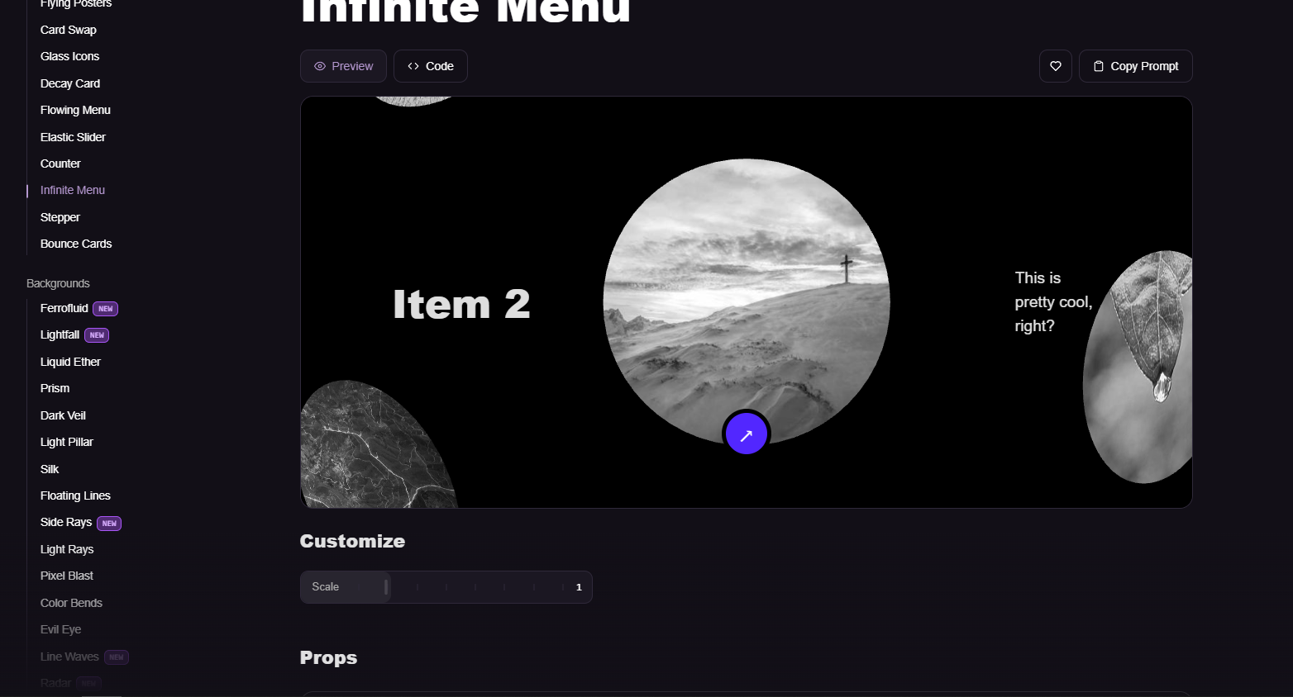

Придерживайся полностью этого гайда. И добавь вкладку Админка откуда можно будет удобно менять видео через панель которые загружены на сайте.

